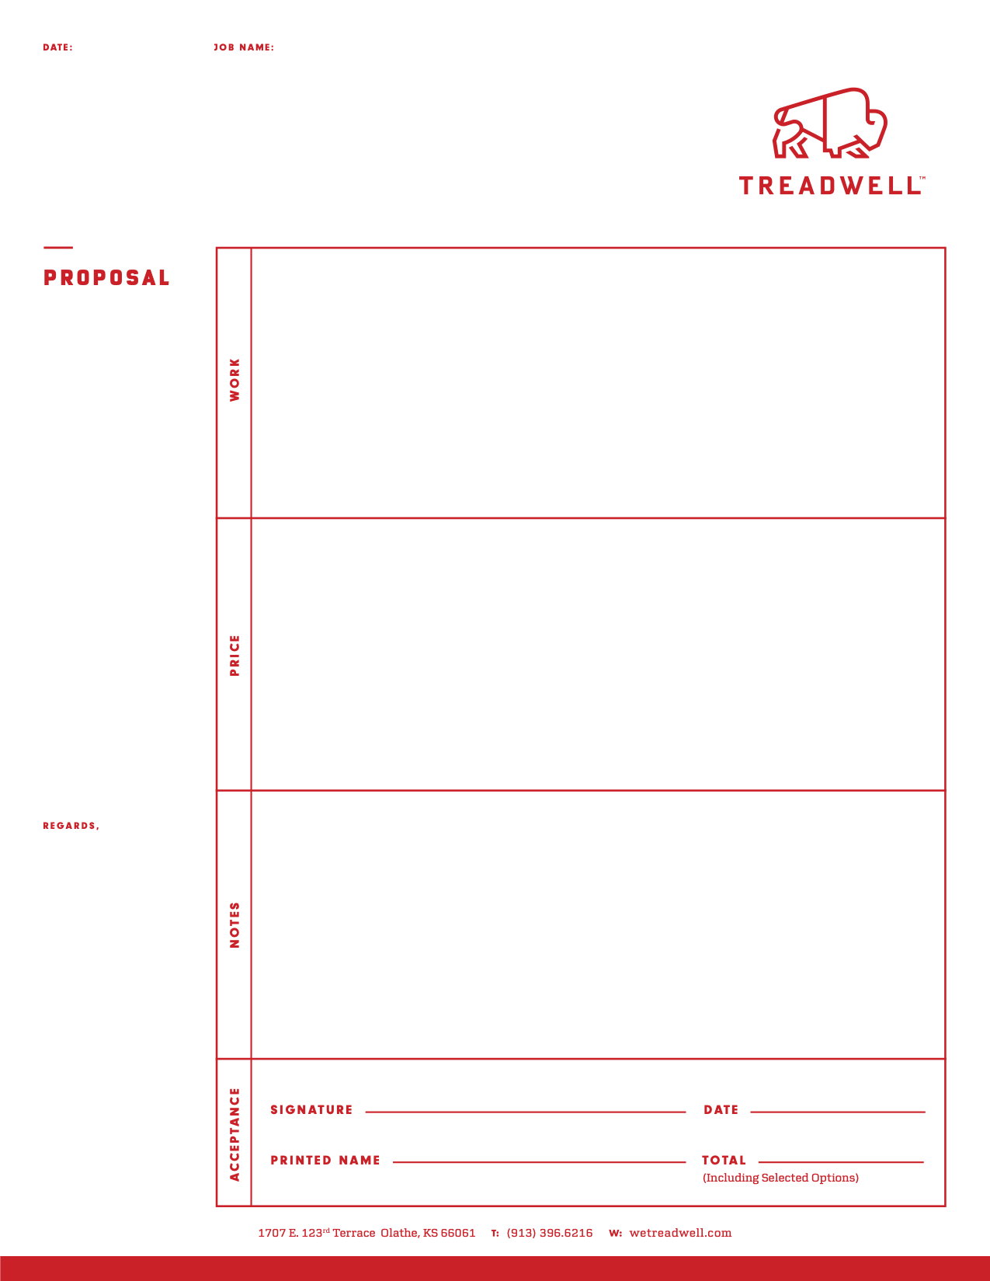
xx
xx, MO

1/1/26

xx

- Flooring Options for Warehouses

- Areas: South Warehouse 24,260
North Warehouse 8,800

Floor Budget Pricing Options
- $1.15 / sf – Clean & Seal with penetrating sealer
- $1.50 / sf – Grind & Seal with Clear Epoxy
- $2.25 / sf – Grind & Seal with Clear Epoxy + Urethane
- $5.75 / sf – Industrial Solid Color Epoxy + Urethane Topcoat
- $6.75 / sf – Urethane Cement Mortar Overlay

Add On’s
- $3.50 / lf – Clean out concrete joints and fill with polyurea joint filler
- $6.50 / lf – Epoxy line striping

